Global Positioning System Capture and Process System for
Wireless Sensor Networks

Cory Shirts
Eidy C. Herrera
Hartman D. Rector
Jacob J. Johns
Kerry R. Wiser

ADVISOR : Behrouz Farhang

SENIOR THESIS
APRIL 9, 2010

UNIVERSITY OF UTAH
DEPARTMENT OF ELECTRICAL AND COMPUTER ENGINEERING
TABLE OF CONTENTS

Table of Contents ii
List of Figures iv
Abstract 1
- Introduction 2
- Hardware Design 3
  - Building Prototypes ................................................. 4
    - Overview 4
    - Microcontroller 4
    - Accelerometer............................................................................. 5
    - Flash Memory........................................................................... 5
    - GPS Radio................................................................................. 7
    - Multiplexer................................................................................ 8
  - Hardware Improvement....................................................................... 9
- Embedded Programming Design 10
  - Low Power Programming 10
  - Wake-up pin........................................................................................ 10
  - Implementation for the Accelerometer............................................... 10
    - Detecting Motion from the Accelerometer............................... 11
    - A/D Mode of Measurement...................................................... 11
    - Establishing a Baseline............................................................. 12
  - Real Time Clock................................................................................... 12
    - RTC Functions 12
  - Flash Drive and GPS Design................................................................ 13
  - Communication Between PC and Processor........................................ 13
    - USB Implementation.................................................................. 14
    - GUI Design................................................................................ 14
- Post-Processing of GPS Data 14
  - The Issue.............................................................................................. 15
  - The Solution 15
    - Verifying the Matlab Software.................................................. 16
    - Using Matlab............................................................................. 17
    - Creating a RINEX file............................................................... 18
    - Obtaining Ephemerides Data.................................................... 19
    - Obtaining Receiver’s Position.................................................. 19
- Testing 20
- Results and Conclusion 21
References 22
Appendix.............................................................................................................. 23

LIST OF FIGURES

Figure 1.1 Satellites needed to determine Coordinates 2
Figure 1.2 Manufactured Board from 2008-09 Group 3
Figure 2.1 a. Flash Memory PCB Layout. b. Unpopulated Flash
Memory PCB 6
Figure 2.2 Assembled Flash Memory Break-out Board 6
Figure 2.3 Assembled GPS Daughter Board 7
Figure 2.4 GPS Main Board Layout 8
Figure 2.5 a. Multiplexer Schematic. b. Multiplexer Layout 8
Figure 2.6 Assembled Multiplexer Break-out Board 9
Figure 4.1 Position of four satellites SVNi and signal travel distance ρi
needed to compute the user position 15
Figure 4.2 GPS navigation data structure 16
Figure 4.3 Coordinates found in Matlab 17
Figure 4.4 Created Observations RINEX file 19
Figure 4.5 Teqc command to compare RINEX files 20
Figure 4.6 File produced by teqc with receiver’s coordinates 20
ABSTRACT
In partnership with Sandia National Laboratories, a low power GPS tracking unit is developed. The microcontroller-based unit periodically captures short GPS samples and stores them on a flash drive. The samples are later transferred to a personal computer, where the data is then processed and the location of each sample is determined. The work of this team is to refine and implement the design for the system that was developed by a previous team. The previous hardware design is revised and prototypes are manufactured to allow testing and make improvements. For the embedded design, the code for the different components of the system is written, as well as the design of the post processing of the captured GPS data to determine the board position.

1.0 INTRODUCTION
A GPS (full name Navigation System with Timing And Ranging Global Positioning System) is an operational GNSS (Global Navigation Satellite System), which utilizes Satellite Navigation to accurately determine position and time anywhere on the Earth. Satellite Navigation Systems use at least four satellites, as seen in Figure 1.1, to determine the desired coordinates Longitude, Latitude, Altitude and time in three-dimensional space [1].
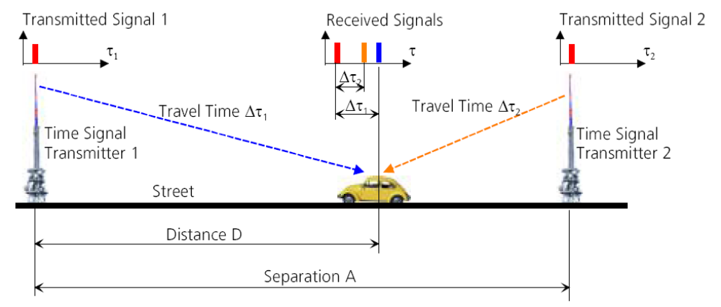
Figure 1.1 Satellites needed to determine Coordinates.

The goal of the senior project for Sandia National Laboratories is to design and build a GPS that would fit to a standardized Sandia stack, be powered just by using 2 CR2 batteries, and capture short acquisitions. This data is stored and then transmitted to a PC to calculate the position of where the samples were taken.
The components of this project are the hardware design, the embedded programming design, and the post processing design. The hardware design requires reviewing the previous design and manufacturing a new board with the appropriate improvements. In the embedded design phase, the code for the microprocessor is written for taking samples, storing them in memory, and downloading them to a PC. The post-processing piece consists of creating code to process the captured GPS data to determine the board positions, and then mapping these sample locations in a user interface on the PC.

2.0 HARDWARE DESIGN
Since this project is a continuation of work performed by the 2008-2009 Clinic Team, the first objective is to review the results from last year. The hardware design from the previous team included an antenna (1575AT43A40E) set at a frequency of 1.5 GHz, a SiGe GNSS receiver (SE4120L) to capture the GPS signal, an accelerometer (ADXL330) to wake up the processor when the chip is being moved, a 128 Mbit Serial Nor Flash (M25128), a Multiplexer (Fairchild 74AC257), and a TI MSP430F169 microprocessor to control the overall system. The objective of this design was to capture the data at the SiGe front-end, store it directly into the serial flash, and transfer it to the PC. The manufactured board from last year’s team is seen in Figure 1.2.
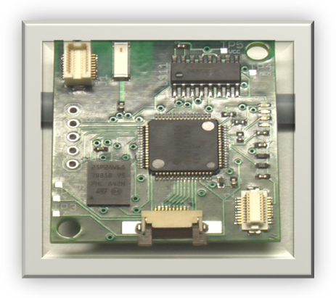
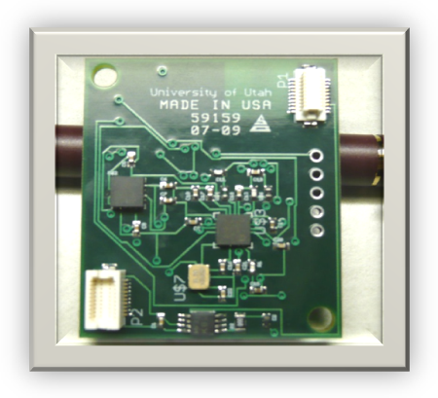
Figure 1.2 Manufactured Board from 2008-09 Group
2.1 Building Prototypes
There are a few concerns when trying to test the manufactured board from the previous team due to the size of the board. The debugging process would take longer than expected, and the components of the circuit could be ruined during testing. The solution found to the problem was to build prototypes, which are easier to modify, test, and debug. These prototypes would facilitate to trace problems, expand functionality, and remove and replace failed components.
2.1.1 Overview
In order to reduce complexity, separate dedicated prototype break-out boards are employed for each functional section of the design, namely: microcontroller, accelerometer, GPS radio, flash memory, and multiplexer. Each break-out board is paired with pin headers for connectivity. This allows connections between break-out boards to be made using jumper wires while some interface directly using pin headers. The break-out boards were acquired either in a nearly preassembled package or assembled by hand by placing components and wires on proto boards and connected by soldering. The proto boards employed are of a particular kind known as stripboards. Stripboards are similar to breadboards in that they connect devices by using parallel orientated conductors but differ in that said devices are soldered in place. This difference allows the use of faster and more complex circuitry than conventional breadboards due to reduced parasitic losses.
2.1.2 Microcontroller
A MSP430 F1000 series test board was available for use from the 2008-2009 clinic team and successfully passed testing. However, due to restrictive limitations in the F1000 series, an MSP430 test board for the F5000 series was acquired to ease development through the use of added features such as increased clock speed and real-time clock improvements. Female pin headers were soldered to the F5000 series test board for connectivity.
2.1.3 Accelerometer
Three ADXL335 accelerometer breakout boards were acquired from Sparkfun Electronics in a ready-to-use package (aside from the installation of a 6-pin header). Two of these breakout boards were hand soldered and successfully passed testing. An untouched third accelerometer was held as a backup.
2.1.4 Flash Memory
During the prototype design phase, it was discovered that due to technical limitations, the flash memory utilized in the previous design is insufficient for use in GNSS storage applications. This delayed the prototype phase for several weeks by redirecting effort into additional design research and consequent design challenges. The result of this research led to the selection of a dual IC solution. The chips in use are Micron 1GB serial flash NAND IC’s packaged in a 63-ball Very Fine pitch Ball Grid Array (VFBGA) that require custom fabricated PCBs for prototype use.
Computer Aided Design (CAD) assisted in schematics design and board layout for the flash memory break-out boards. The 2008-2009 Sandia clinic team used the software application ‘Eagle’ by CadSoft to draw their design. Using Eagle, the schematics from 2008-2009 were imported and reorganized for better readability. Any potentially functional parts of the design were used as a starting point for the prototype designs in order to save time. Eagle library parts were created for the new flash memory IC by following published connection and dimension specifications [3]. The schematic and layout designs for this PCB were drawn in Eagle CAD and sent to Quick Turn Circuits of Salt Lake City for fabrication. The layout and chip are seen in Figure 2.1.
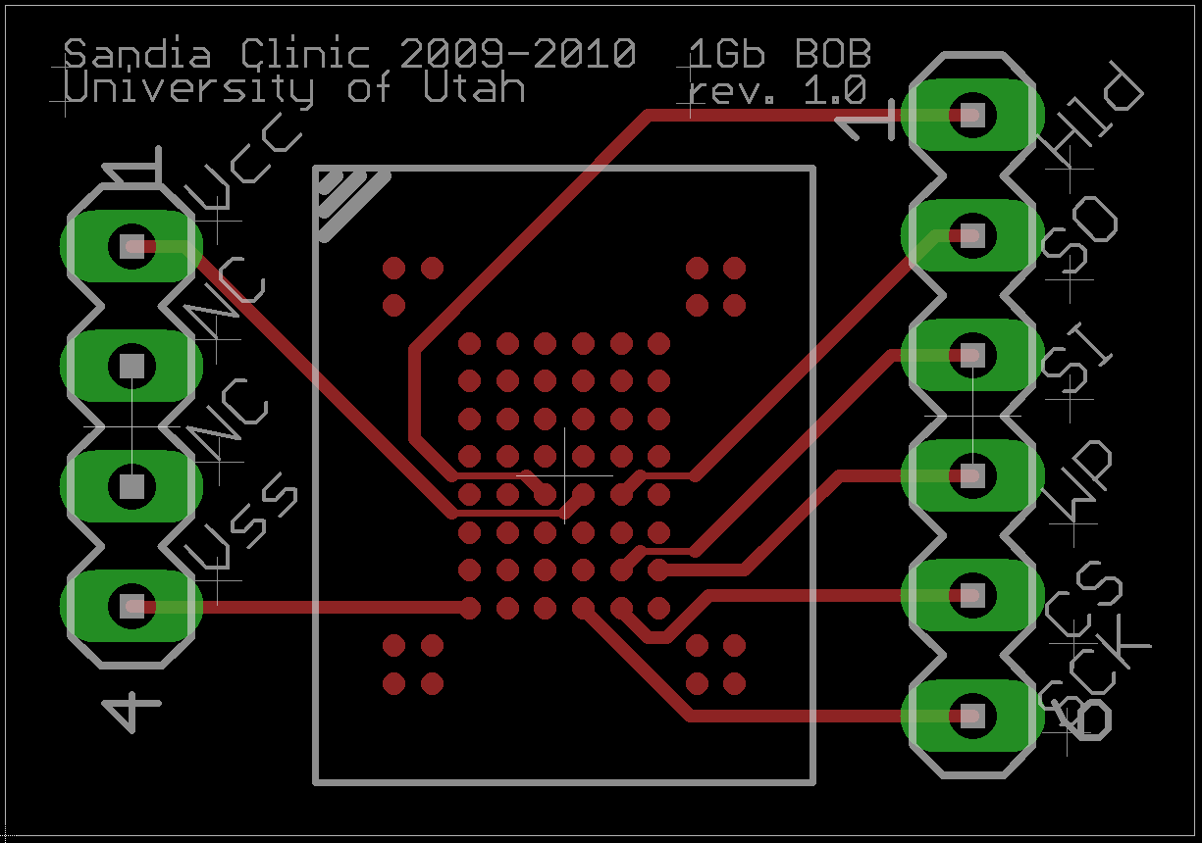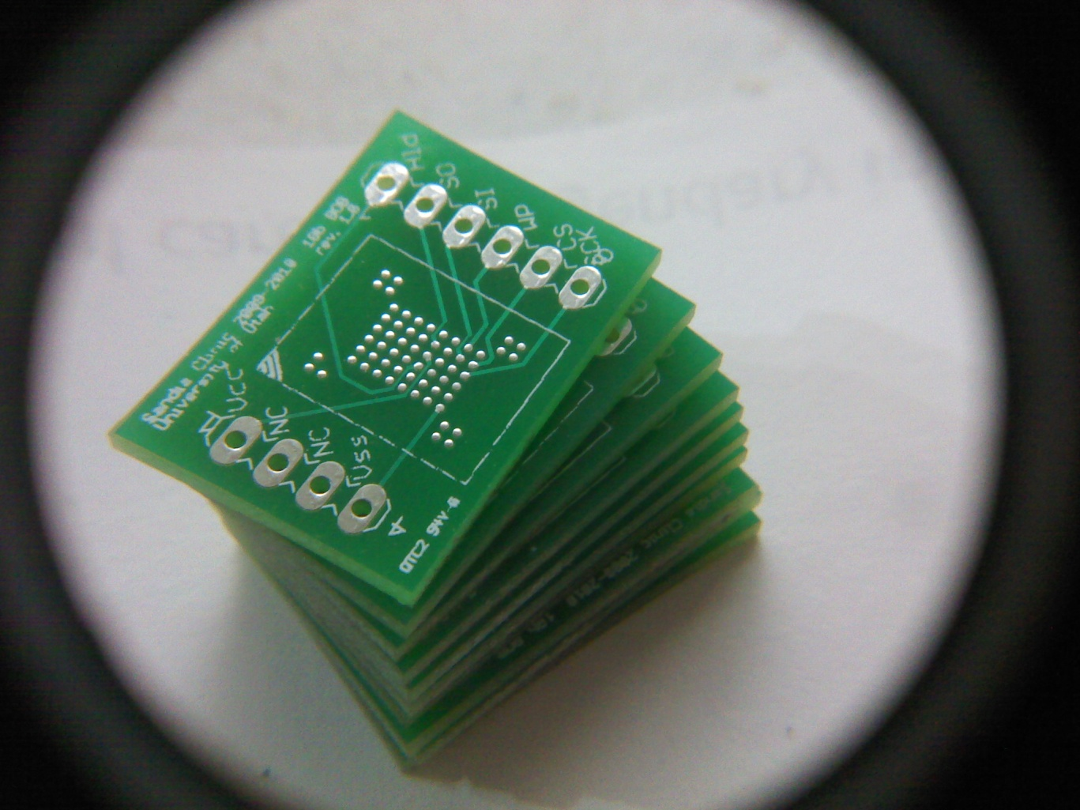
Figure 2.1 a. Flash Memory PCB Layouts. b. Unpopulated Flash Memory PCB

Four of the finished PCBs were sent to PCB Solutions of Layton, Utah for assembly. Upon completion and delivery, pin headers were hand soldered to add connectivity; the result is seen in Figure 2.2.
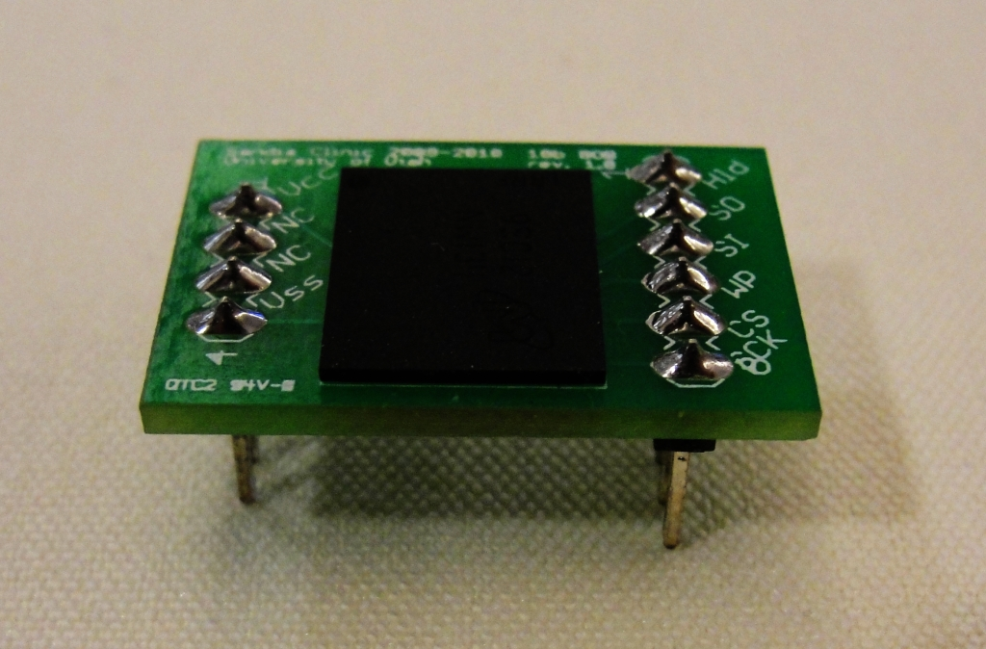
Figure 2.2 Assembled Flash Memory Break-out Board

SD/MMC card break-out boards were acquired from Sparkfun Electronics as an alternate secondary storage solution.

2.1.5 GPS Radio
The SiGe 4120L GNSS receiver is packaged in a 24 pin Quad Flat No-lead package (24-QFN), which—like the flash memory solution—requires the use of a PCB break-out board for prototyping. However, less expensive premade PCBs were available for these parts and subsequently purchased and hand soldered.
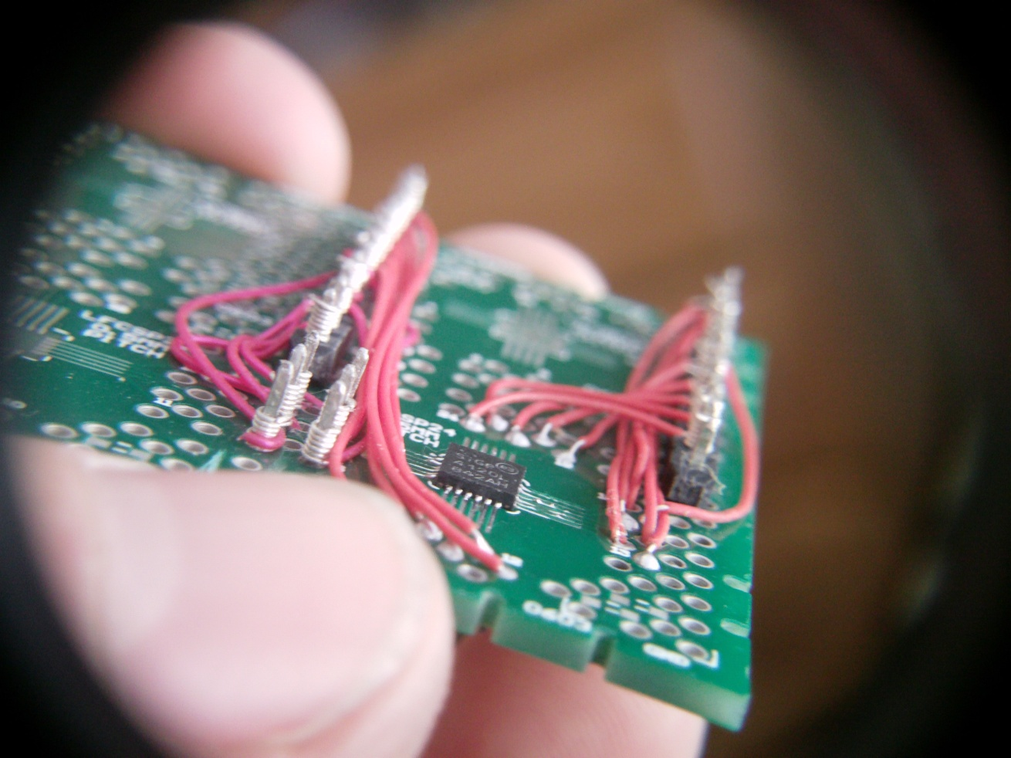
Figure 2.3 Assembled GPS Daughter Board

The assembled break-out board for the SiGe GNSS receiver attaches through pin headers into a GPS main board built on stripboard, see Figure 2.3. The GPS main board houses components for the receiver such as a 16.368 MHz crystal oscillator, antenna, and all passives required for operation. Eagle CAD was used to draw the GPS Radio schematic and layout. To aid with a design built on stripboard, through-hole components were used where possible and placed vertically in the CAD layout using 0.1” spacing between terminals. Pin headers and jumper wires are used to connect boards to each other or to the microcontroller and these are placed in the CAD layout design as well as seen in Figure 2.4.

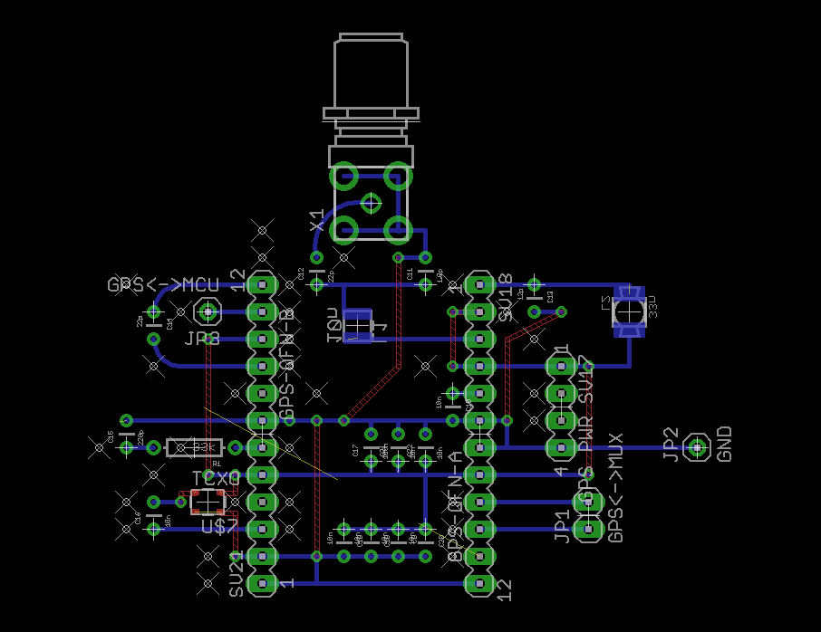
Figure 2.4 GPS Main Board Layout

2.1.6 Multiplexer
The swap from a single flash memory package to a dual IC solution requires the use of a larger multiplexer. Subsequently, this requires redesign of the multiplexer components, the design is seen in Figure 2.5 a. The new multiplexer configuration was assembled on stripboards using dual-inline package (DIP) multiplexer IC’s in the same fashion as the GPS main board, the multiplexer layout is seen in Figure 2.5 b and the assembled
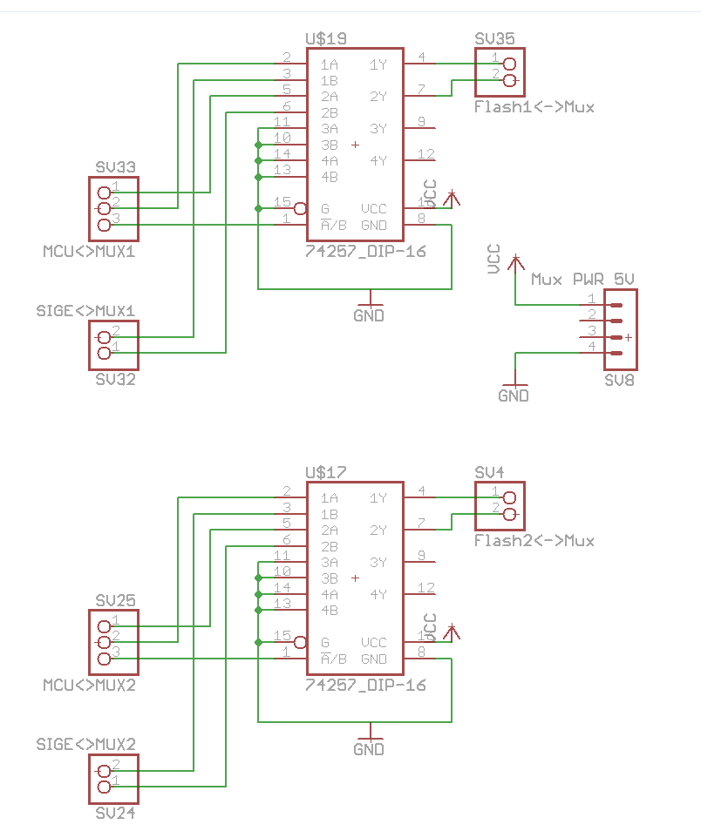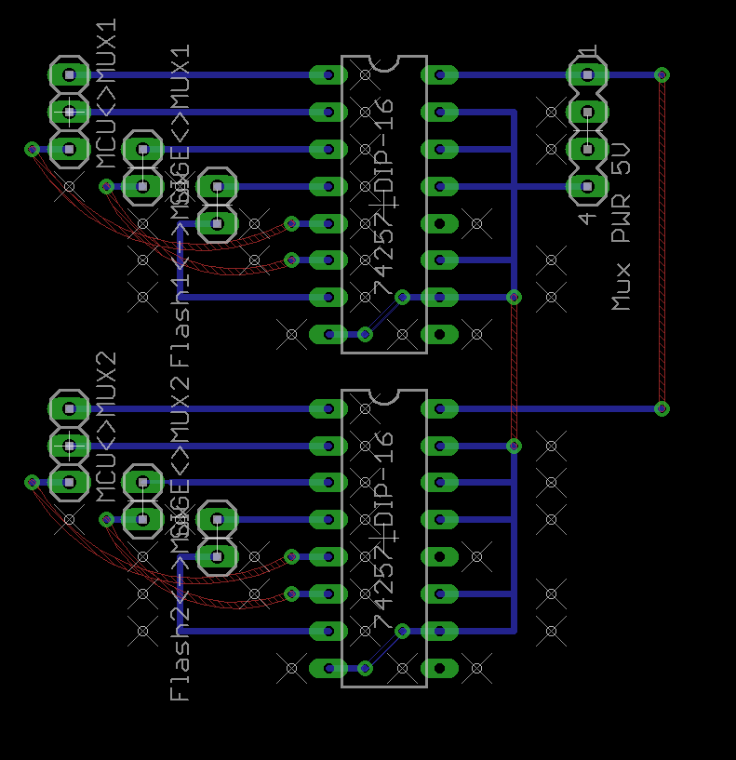
Figure 2.5 a. Multiplexer Schematic b. Multiplexer Layout
multiplexer is observed in figure 2.6.
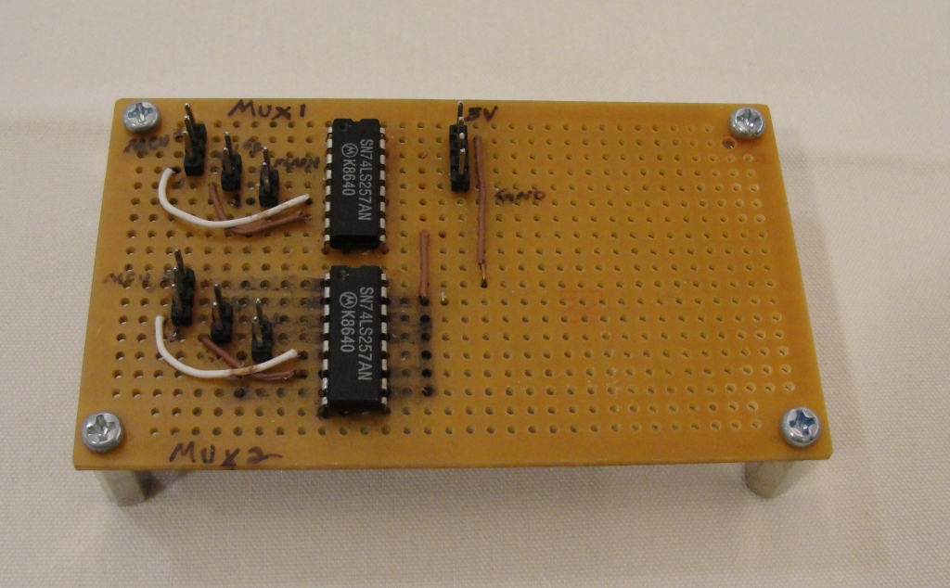
Figure 2.6. Assembled Multiplexer Break-out Board

2.2 Hardware Improvement
Several of the hardware components from last year's design required upgrades. This is because last year’s hardware design is not capable of capturing a continuous 0.2 second signal from the GPS front end. This is due to the speed of the microcontroller and the flash memory. The GPS front end outputs data at 16.368MHZ and the microprocessor from last year's design has a clock speed of 8MHZ. Originally it was thought that this would not cause any problems because the data could be streamed directly into the flash memory. This will not work because the flash memory can only receive 1 page of data and then it will have to be flashed causing long pauses in the data record. Our solution is to use two high performance flash chips each with their own multiplexer that allows commands to be sent from the microcontroller, or data to be captured from the GPS front end. Data can stream from the GPS front end into one flash memory while the other is being flashed. Because these flash chips have a very large page size and fast flash time, the data can be captured directly from the GPS front end without any interruptions.

3.0 EMBEDDED PROGRAMING DESIGN
3.1 Low Power Programming
The MSP430F5529 microprocessor has up to 6 available low power modes. These modes are denoted as LPM0 through LPM5. LPM0 and LPM1 are referred to as active modes, where most of the functionality of the microprocessor is enabled. Each mode has features on the processor that are available for use and others that are disabled in order to consume less power. For example, LPM4 disables all clock signals for the system. The LPM that we use for our system is LPM3, which allows the use of ACLK, a low frequency clock signal, 32.768 kHz, much slower than the max of 25 MHz supported by the processor. This frequency reduction dramatically reduces power consumption that is typical of higher frequency clocks. The use of LPM3 also gives us the ability to use timer interrupts and the real time clock.
3.2 Wake-up pin
A wake-up pin is part of the system because of the need of interoperability with other devices in the Sandia Stack. A device triggers an interrupt by raising a signal high, which brings the system out of LPM3 mode. This functionality allows the system to arbitrarily wake up and gather needed GPS samples. The interrupt is manually disabled after the system is taken into an active mode.
3.3 Implementation for the Accelerometer
The ADLX335 accelerometer outputs three analog voltages corresponding to the X, Y, and Z axes of motion. The voltages are proportional to the acceleration it is detecting, which allows an A/D converter on the microprocessor to convert the analog signals into digital values. We take a handful of these signals and average them, eliminating high and low values to account for possible spikes in noise. If the averaged signal values are beyond a threshold, movement has been detected from the accelerometer. All of this is done in the low power mode suitable for the application. Once movement is detected, the processor wakes up and begins the process of collecting and storing GPS data.
3.3.1 Detecting Motion from the Accelerometer
There are various methods to periodically measure the analog voltage outputs from the accelerometer. The different methods allow different levels of control, controlling when and how often measurements are taken. The options on the A/D converter that allow for as much control as possible are used. A timer is set up to interrupt approximately once per second and trigger the voltage measurements manually. If the trigger was already set previously, the interrupt checks if the desired number of measurements have been taken.
When this point is reached, the stored measurements are averaged in the manner described previously. If the difference between this average value and the baseline is greater than the threshold value for one of the inputs, this is interpreted as motion and the interrupt wakes the CPU out of LPM3. The threshold is calculated by testing the accelerometer with hundreds of measurements in a stationary atmosphere and recording the range of values that came of it. Further measurements and research can be done to quantify this threshold and fit it to the specifications of the ADXL335.
3.3.2 A/D Mode of Measurement
Once triggered, the A/D takes measurements of the X, Y, and Z inputs in what is called Repeat-Sequence-of-Channels mode. In this mode, the A/D converter measures the voltages of the inputs and stores them, repeating this until the desired number of measurements has been taken. This enables the processor to gather measurements that are close together and do it in a short amount of time.
3.3.3 Establishing a Baseline
The first time the A/D conversion is triggered, the system averages 34 A/D measurements, eliminating the max and min as described above, as a baseline. This value is used to show the value of the input if it were in a stationary environment. This assumes that the code will be uploaded and executed immediately, keeping the unit stationary for a few moments, allowing this measurement to be accurate. When the A/D conversion is triggered after this, 10 samples are taken.
3.4 REAL TIME CLOCK
Another part of this design is the need to use a real time clock. Recording a timestamp helps finding the rest of the satellite information from a small sample recorded. It was originally decided to have a separate RTC (Real Time Clock), because the one on the processor that was used the previous year did not run in low power mode. However, with an upgrade to a faster processor the RTC on the processor can be used because on the new processor it will keep the clock going even in low power mode. The RTC is used for a timestamp and maybe to make the processor take a measurement every once in a while even if it has not moved.
3.4.1 RTC Functions
The functions available for use consist of getting the time setting the time and these different interrupts: every minute, every hour, everyday at noon, and everyday at midnight. There is also the possibility of setting an alarm to go off once a week. The functions can be found in the code and make it very easy to set up the different interrupt and to set and get the time.
3.5 Flash Drive and GPS Design
The integration of the flash memory and GPS front end requires custom embedded software. Software routines to send commands to the flash memory chips have been written. These commands are RESET, WRITE ENABLE, GET FEATURES, PAGE READ, RANDOM DATA READ, PROGRAM LOAD, PROGRAM EXECUTE, and BLOCK ERASE. When a sample is being collected data is streamed from the GPS front end into the first flash memory. The program then enters a software loop. In the loop the multiplexers are switched and the PROGRAM EXECUTE command is issued to the first flash memory and we wait for the device to program. While this is happening data is streaming from the GPS front end directly into the other flash memory. When the PROGRAM EXECUTE command finishes the WRITE ENABLE and PROGRAM LOAD commands are issued. This makes the flash device ready for the next data capture. The loop then repeats. This loop enables us to take uninterrupted samples for the desired length of 12 seconds.
3.6 Communication Between PC and Processor
A part of the design also includes getting the information from the processor to the PC so that post processing can be accomplished and give the coordinates of where the device has been. Originally communication using a serial interface was decided; however during the implementation of the flash, the possibility to communicate over USB was found. The switch to the USB was made. As part of the design, a simple GUI is created to make it easier for the user to gather the information needed.
3.6.1 USB Implementation
There was some example code available from Texas Instruments that creates a virtual com port (serial port) to connect to the computer via USB port. This allows us to use the USB port as if it were a serial port, which makes creating a GUI much easier. The communication between the processor and the computer serves two purposes. First, to set the RTC to the right time, and second to gather the information stored on the flash. Currently, the raw data from the GPS antenna is being gathered so there is be no need to do any parsing and the GUI just needs to gather the data and save it into a bin file to be used in post processing.
3.6.2 GUI Design
To get the information off the processor as easy as possible for the user, a GUI is created. It is a very simple GUI. All it does is take the time in year, month, day, hour, minute, second, and then has a button to receive. Also there is a way to set the com port that is desired to use (it will be the virtual com port created by the processor). Then it prompts the user to pick a location to save the file and gathers the data and saves it to that location. At this point the file is ready for post processing.

4.0 POST-PRCESSING OF GPS DATA
Once the data is transferred to the computer, it needs to be processed to obtain the position of the board when the samples were captured. For this process, a minimum of four satellites information needs to be present in the signal received as seen in Figure 4.1. In order to compute the position two main parameters are needed: pseudoranges and ephemerides data for each satellite present in the received signal. Pseudoranges are the distances between the satellites and the receiver, and ephemeris data provides the satellites positions at any specific time. [2].
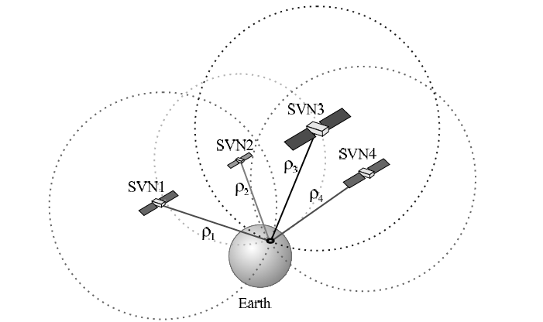
Figure 4.1 Position of four satellites SVNi and signal travel distance ρi needed to compute the user position.
4.1 The Issue
To calculate the receiver’s position, there is a Matlab based software available with the book A Software-Defined GPS and Galileo Receiver: A Single-Frequency Approach. However, to produce the desired coordinates this software requires a minimum of 37 seconds of GPS data, which is equivalent to over 600 MB of data. Capturing such a large sample would require more power consumption and a lengthy tracking process of close to 30 minutes. In order to maintain the low power consumption of the system, post-processing needs to be accomplished with a smaller sample.
4.2 The Solution
The Matlab software requires a large signal because the GPS navigation data structure is
divided into frames, which are separated into five subframes of six seconds each. The subframes 1, 2, and 3 are repeated every 30 s; as shown in Figure 4.2 in these first subframes the needed satellite ephemeris information is found [2].
Nevertheless, GPS ephemerides data are stored and can be found online in a positioning service website. The new approach to process small data is integrating an incomplete sample with stored GPS ephemerides to obtain the receivers position. Accordingly, the existing Matlab code is used to obtain pseudoranges and GPS the time of the transmission, the ephemerides are acquired online, and both records are combined to compute the position coordinates.
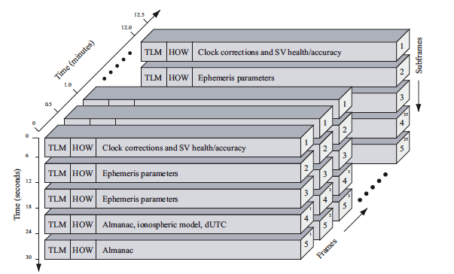
Figure 4.2 GPS navigation data structure
4.2.1 Verifying the Matlab Software
The first step in creating this new method is to understand the principles of GPS signal processing and to verify the usability of the existing Matlab software. The Matlab software performs the acquisition, tracking, and position solution in the same code. Acquisition identifies all the satellites in the received signal and its properties. Tracking keeps track of the signal properties over time demodulating the navigating signal. The navigation solution part computes pseudoranges and decodes ephemerides [2]. To verify the accuracy of the code a large sample of 40 seconds was captured at a known location. The data was processed using Matlab and the code reveals the calculated coordinates in a plot as shown in Figure 4.3 in the measurements box. The coordinates matched the location where the data was captured, which verifies that the code works properly.
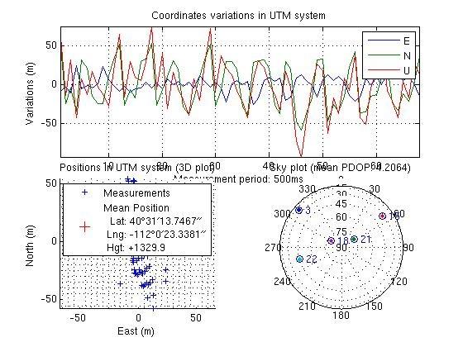
Figure 4.3 Coordinates found in Matlab
4.2.2 Using Matlab
Now that the Matlab code has been verified for, part of it can be used to start the post-processing of a smaller sample. In the first attempt, samples were captured of different lengths 30, 16, 12, and 6 seconds to be processed. However since each new small sample contained different satellites and different parameters there was not a way to test if the results obtained at each stage were correct. To solve this issue, a function was created to extract the desired length of data from the 40 seconds sample, in that way the results of each step was verified, for example when acquisition was performed its results were compared to the results of the big sample.
A 12 s sample is extracted from the 40 s one and then acquisition and tracking are performed in Matlab. By understanding the process the code follows, it is determined that with 12 sec tracking can be accomplished successfully but not navigation solutions. When using this smaller sample the tracking time is reduced from 30 to about 3 minutes since there are only 2 subframes used. Then the ephemerides decoding part is omitted since there is not enough data. However valid pseudoranges can be computed by finding first the beginning of a subframe, based on that measurement the arrival time of the signal is obtained. Pseudoranges are then calculated by multiplying the travel time from the satellite to receiver by the speed of light [2]. Since the code was expecting to process ephemerides before calculating pseudoranges, pseudoranges and the GPS time of the week are computed based on just the start of the 1st subframe without requiring more data. Finding the accurate time of transmission is crucial since receiver clocks are not synchronized with satellite clocks, and any second variation causes a big difference in the position calculated.
4.2.3 Creating a RINEX file
RINEX, which means Receiver Independent Exchange Format, is a popular storage format for GPS observation or navigation data [4]. After obtaining correct pseudoranges and the TOW, a RINEX file is created with this information. First the calculated TOW needs to be converted to UTC (Coordinated Universal Time), for example in the test sample the computed time of the week in seconds was 105636, which converted to UTC was 29 hours 20 minutes & 36 s from the start of the GPS week, which starts on Sunday.
The type of file written was an observation one; a simple text editor is used to write it. However, there are many complications due to the lack of clarity on the instructions for such a strict format. For example, the instructions require a list of visible satellites, but it never specifies the character spacing needed and if the format is not exact the file cannot be read. The created file can be seen in Figure 4.4.
4.2.4 Obtaining Ephemerides Data
In order to obtain the missing ephemerides data, the IGS (International GNSS Service) website can be used. This website provides stored GPS ephemerides in RINEX navigation type of file based on the time and date of capture. The file name format follows the structure namedddh.yyn, where ddd represents the day of the year (1-366), h is a letter for hour of day (a-x=0-23), and yy are the 2-digit year. [5]

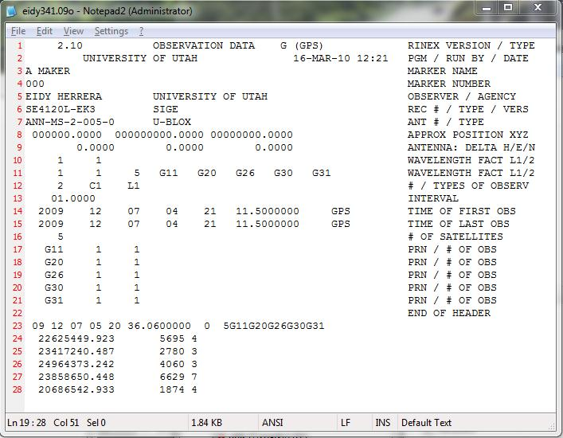
Figure 4.4 Created Observations RINEX file
4.2.5 Obtaining Receiver’s Position
Once the navigation RINEX file is found online with the satellite ephemerides, it needs to be combined with the observations file that was typed earlier. To accomplish this, a toolkit for GPS created by UNAVCO called teqc is used. The teqc tool translates, edits, and checks the quality of data files [6]. By using the command shown in Figure 4.5, the program compares the written observations file containing the pseudoranges with the navigation file of ephemerides found online. After comparing the two files, the system creates a quality check file that contains the receiver’s coordinates as seen in figure 4.6.

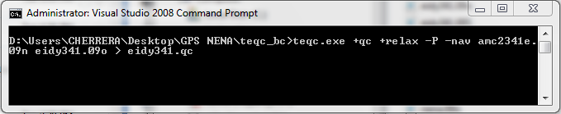
Figure 4.5 Teqc command to compare RINEX files
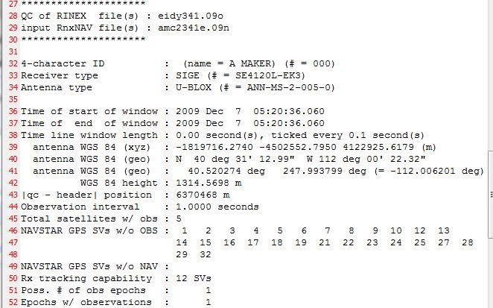
Figure 4.6 File produced by teqc with receiver’s coordinates

Finally the coordinates found can be mapped using google maps for better visibility.
5.0 Testing
Testing the system consists of verifying the functionality of individual components and the integrated system. One tool for testing is the IAR Embedded Workbench Kickstart [7] is a development tool used in developing embedded code for the project. Kickstart contains a debugger, which allows access to register and memory values through the connection to our test board. Other tools for testing include 10x probes, an oscilloscope, and meters for measuring voltages and currents. These are used for verifying the correct timing and placement of signals, showing correct output from the processor and accurate communication between the processor and the various components. Future testing efforts will be focused on integrating the system and measuring power consumption.
6.0 Results and Conclusion
In partnership with Sandia National Laboratories, a low power tracking system is developed using a microcontroller based unit. The unit operates in low power and only initiates GPS sampling periodically through the use of an accelerometer and an external wakeup signal. Short samples are stored on flash chips until they can be transferred to a personal computer for processing, after which the whereabouts of the device are determined. Further testing and integration efforts are needed to verify functionality and determine if the results satisfy the requirements given by Sandia National Laboratories.
REFERENCES
[1] U-blox AG, “Essentials of Satellite Navigation,” Compendium, Apr. 26,2007.
[2] K. Borre, D. M. Akos, N Bertelsen, P. Rinder, and S. H. Jensen, A Software-Defined GPS and Galileo Receiver: A Single-Frequency Approach (Applied and Numerical Harmonic Analysis). Boston, MA: Birkhäuser 2007.
[3] Micron, NAND Flash Memory Serial Peripheral Interface (SPI) MT29F1G01ZAC, [Confidential Datasheet], Rev. A 5/09.
[4] RINEX: The Receiver Independent Exchange Format Version 2.10 10 Dec. 2007. 01 Mar. 2010 <http://igscb.jpl.nasa.gov/igscb/data/format/rinex210.txt> .
[5] IGS Data 07 Mar. 2005. 01 Feb. 2010 <http://igscb.jpl.nasa.gov/components/data.html>.
[6] TEQC — The Toolkit for GPS/GLONASS/Galileo/SBAS Data 17 Mar. 2010. 03 Mar. 2010 <http://facility.unavco.org/software/teqc/teqc.html>.
[7] IAR Embedded Workbench Kickstart - Free 4KB IDE - IAR-KICKSTART - TI Tool Folder 9 April 2010. <http://focus.ti.com/docs/toolsw/folders/print/iar-kickstart.html>
APPENDIX
Few ethical issues were encountered during the completion of this project. However, one issue is the overall ethics of a tracking device, for it could potentially be used to keep track of a person’s whereabouts, without their prior knowledge or consent. This issue had little impact on the project because the size of the device makes it quite inconspicuous.
The existence and use of a device such as this is unlikely to pose a threat to the environment or to the safety of individuals. However, this technology can be used as a concealed tracking device and could raise privacy issues if abused. This risk is offset by the benefits seen when used in other ways. For example, this technology could be used to help ensure safe transport of sensitive materials. It could also be used to locate unsafe conditions in a mineshaft through the use of external sensors which can detect harmful substances. It can also help further research into biological systems such as migratory patterns if attached to an animal.

